This is a picture of the piggery, where the sensor will be housed:

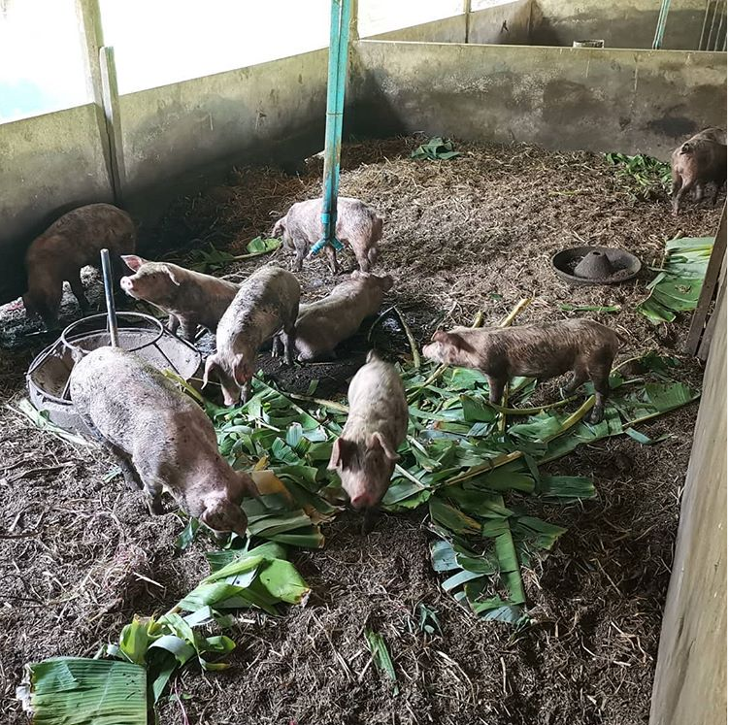

As our sensor housing is white abs plastic which is designed to be mounted on a wooden post, we believe it is aesthetically inoffensive within that environment.

Additionally, our receiver is a simple black molded plastic box, which will also inherently blend in with any environment.